Organ | Picture | Function
Kidney | 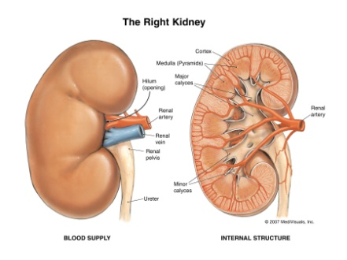 | This pair of fist-sized organs is responsible for removing urea from the blood and turning the bodily waste products and excess fluids into urine.
Ureter | 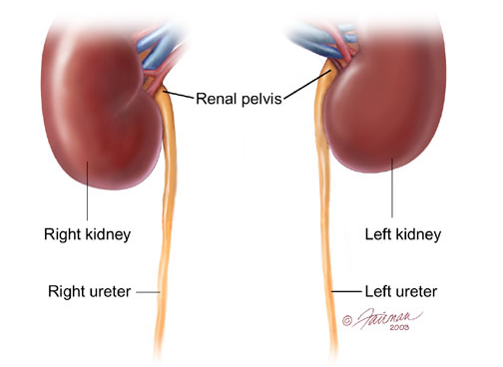 | These tubes, anywhere from 8 to 10 inches in length, use muscle contractions to push out the urine formed in the kidneys and empty it into the bladder.
Bladder | 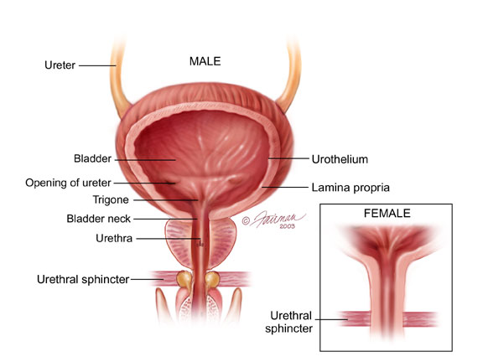 | The bladder is a round, hollow organ that receives the urine from the ureters and holds it until it can be excreted from the body.
Sphincter | 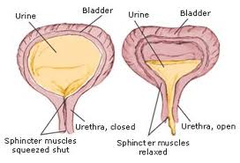 | The sphincter is a small round muscle located at the opening of the bladder. It keeps the bladder closed to prevent leaking urine out until the body is ready. When the body urinates, this muscle can relax to allow the urine out.
Urethra | 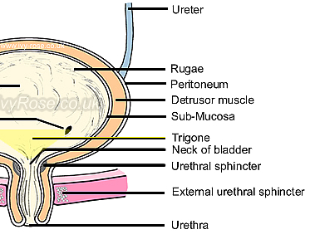 | The urethra is the opening at the end of the bladder that brings the urine outside the body to excrete the waste and excess water processed by the urinary system.

