Glands of the Human Endocrine System | Name | Hormones Secreted | Function
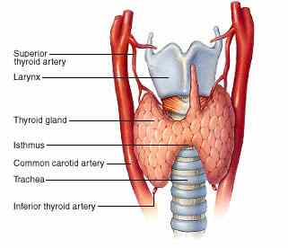 | Thyroid Gland | Thyroxin | The release of thyroid hormones is controlled by the pituitary gland. This gland in the neck region is responsible for regulating metabolism in people of all ages as well as skeletal and nervous system growth and development in children. The thyroid hormones also assist in the regulation of heart rate, blood pressure, muscle tone, reproduction, and digestion.
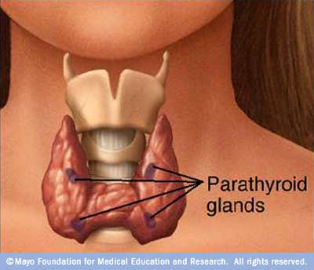 | Parathyroid Gland | Parathyroid Hormone | These smaller glands are located on the thyroid gland’s surface. They are responsible for the regulation of blood calcium levels as well as bone metabolism.
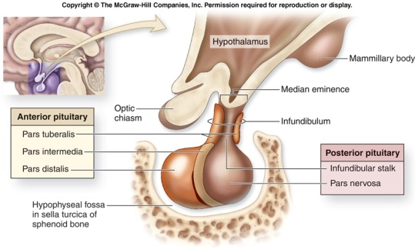 | Pituitary Gland | TSH, ACTH, LH, FSH, Prolactin, Growth Hormone, Oxytocin, and Vasopressin | About the size of a pea, the Pituitary gland is located near the base of the brain. This structure has been referred to as the most important component of the endocrine system because its hormones are responsible for the regulation of numerous other endocrine glands. Some examples of its regulations follow:  Growth Hormone stimulates the growth of tissues and bones, Thyroid-Stimulating Hormone controls the production of thyroid hormones, Adrenocorticotropin Hormone controls the Adrenal Gland, Prolactin stimulates female milk production, Lutenizing and follicle stimulating-hormone control reproductive functions, Antidiuretic Hormone controls water loss from the kidneys, and oxytocin plays a role in childbirth and milk production as well.
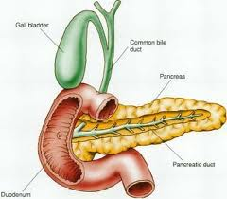 | Pancreas | Insulin and Glucogen | The pancreas is an organ located behind the stomach. It is primarily responsible for the release of digestive enzymes used to break down food. These are released from the exocrine pancreas. The endocrine portion of the pancreas, however, secretes the hormones that regulate the body’s blood glucose levels
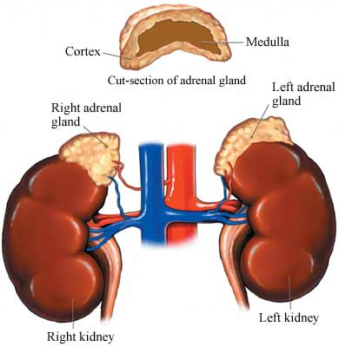 | Adrenal Glands | Epinephrine, Nonepinephrine, and Adrenaline | The adrenal glands are located on top of the kidneys. There is an inner and outer part to these glands. The adrenal cortex, or outer portion, secretes corticosteroids which control the body’s stress response, immune and sexual functions, metabolism, as well as salt and water levels in the body. The inner portion, called the adrenal medulla, releases catecholamines which control the body’s physical and emotional stress responses in its regulation of heart rate and blood pressure.
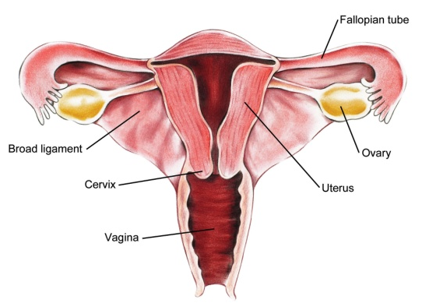 | Ovaries | Estrogen and Progesterone | These hormones play a large role in reproduction. The estrogen released is responsible for the development of secondary sex characteristics and aids in the production of eggs. The progesterone is responsible for preparing the uterus to hold the fertilized egg. These hormones also regulate the menstrual and pregnancy cycles.
 | Testes | Androgens such as Testosterone | As estrogen produced eggs and secondary sex characteristics for females, testosterone produces male secondary sex characteristics and the sperm used to fertilize the female eggs.
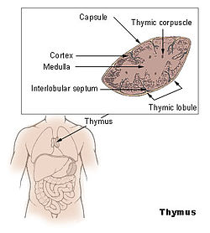 | Thymus | Thymosin | The thymus is most active during childhood and is located in the upper chest area of the body. It regulates immunity in its production of the T lymphocyte immune cells.
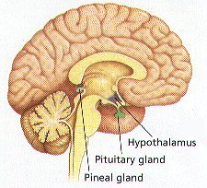 | Pineal Gland | Melatonin | This structure is located near the center of the brain. The hormone melatonin controls the body’s internal sleep clock.
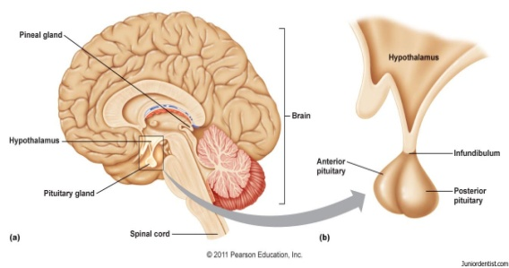 | Hypothalamus Gland | Dopamine, Somatostatin, CRH, GHRH, GnRH, and TRH | Located in the lower region of the brain, the hypothalamus plays an important role in the nervous system. The hypothalamus’s hormones are responsible for controlling the pituitary glands functions.

