Organ | Description | Enzymes Secreted | What it breaks down…
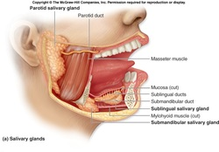  Mouth | The mouth is the beginning of the digestive tract where food first enters and is chewed to begin the digestive process. | Salivary amylase | Begins to physically break down the food by chewing it into smaller pieces.  Saliva begins the breakdown of starches
Esophagus  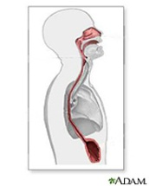 | The muscular esophagus takes the food from the mouth to the stomach. | ---------- | Mainly for transporting food to stomach to be further broken down
Stomach  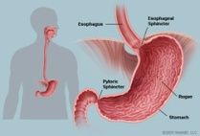 | The stomach is a hollow pocket full of acid and enzymes that holds and churns the food as it is being broken down. | Digestive juices- pepsin  Gastric juices secreted whenever the brain signals that the body is going to be consuming food. | The stomach contains a mixture of digestive juices that are highly acidic and begin the breakdown of proteins.
Small Intestine  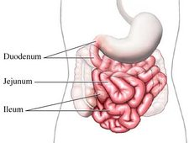 | The Small intestine is an incredibly long organ that consists of three portions- the duodenum, the jejunum, and the ileum. It further mixes the food with digestive enzymes and in the lower portions it begins the process of absorbing nutrients into the bloodstream for use by the rest of the body. | Receives a variety of enzymes from the gall bladder, pancreas, and liver such as bile and other digestive enzymes  Maltase  Peptidases | Removes nutrients from foods and breaks down carbohydrates, lipids, and proteins.  Breaks peptides into amino acids and digests disaccharides.
Pancreas  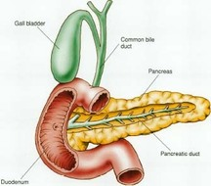 | The Pancreas releases digestive enzymes into the duodenum portion of the small intestine. It is also vital for insulin production to regulate blood sugar. | Digestive Enzymes  Insulin  Pancreatic amylase, Trypsin, Chymotrypsin, and lipase | Its digestive enzymes help to break down everything from proteins to fats to carbohydrates  Insulin metabolizes sugar.  Breaks down proteins into peptides.  Breaks fats into monoglycerides and fatty acids.
Liver  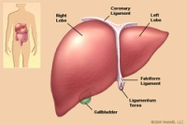 | The liver processes nutrients and creates essential chemicals from consumed materials already processed by the small intestine. It is also important for removing toxins from the body. | Bile | Fats  Drugs and other chemicals  Bile acts as an emulsifier, allowing the fats to mix with water for digestive purposes
Gall Bladder  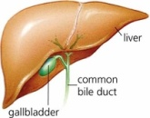 | Stores the bile that is to be released into the duodenum. | Bile | Fat absorption and digestion
Large Intestine (Colon)  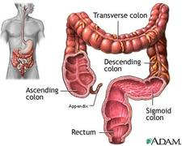 | Consisting of around 6ft. of muscular tissue, the colon has multiple sections: the cecum and the ascending, transverse, descending, and sigmoid colons. The colon receives digestive wastes and processes them by first removing water from the wastes. | Special bacteria | The bacteria synthesize vitamins, protect against dangerous bacteria, and further break down waste/food remnants.
Rectum and Anus  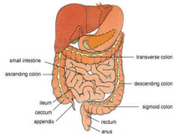 | The rectum connects to the anus and the colon. The colon empties its waste into the rectum where it is stored until it can be excreted from the body. The anus is a small canal that brings the waste to the end of the digestive tract and outside of the body. | ---------- | Removes the final waste
Sources: http://my.clevelandclinic.org/anatomy/digestive_system/hic_the_structure_and_function_of_the_digestive_system.aspx
http://faculty.clintoncc.suny.edu/faculty/michael.gregory/files/bio%20102/bio%20102%20lectures/digestive%20system/digestive%20system.htm

